**Group members**

Dang Thi Thao My - 15905067

Bui Nguyen Thien Khanh - 15907679

Nguyen Anh Quan - 15905072

Le Huynh Anh Tuan - 1325907

**Supervisor:** MSc. Truong Phuoc Loc

**Product Owner:** Mr. To Hoa Duy Man

**USER GUIDE**

**Performance testing dashboard**

Version 1.0 – Released date: 05/16/2017

**Status**:

Approved by:

Released by: Capstone team (ETI1)

Internal

Document Revision History

|  |  |  |  |
| --- | --- | --- | --- |
| Version | Date | Changed by | Modifications |
| 1.0 | 05.16.2017 | Team | Initial version |

Contents

1. Login 1

2. Register new member 2

3. Admin 3

3.1. Admin view for Perforamnce testing Dashboard 3

3.2. Created/Edit Entities 3

3.3. Project management 4

3.4. Group management 5

3.5. Jmeter configuration management 6

4. Users 7

4.1. For Users as Testers 7

4.2. Profile management 12

4.3. Users as Project Mangers 12

# Login

Before using the Performance Testing Dashboard, the testers need to have an accountID. If the testers own one, please proceed login and click “SIGN IN” button. If not, please click “Register a new membership”.

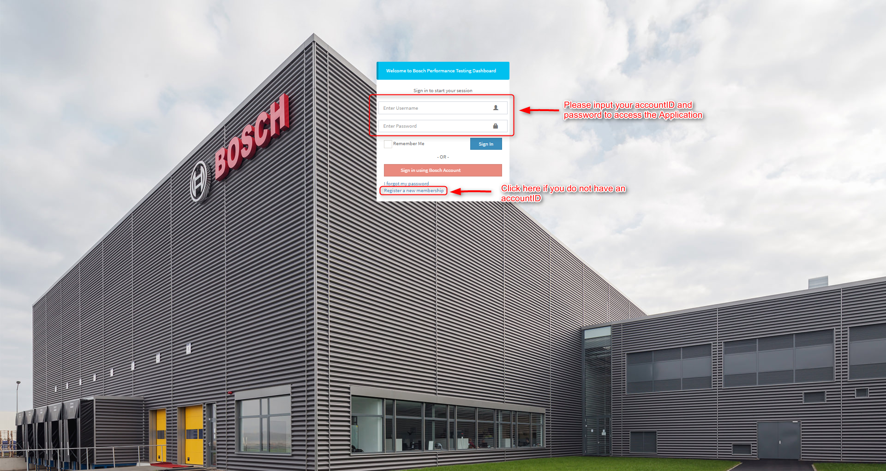

Figure 1 Login form

# Register new member

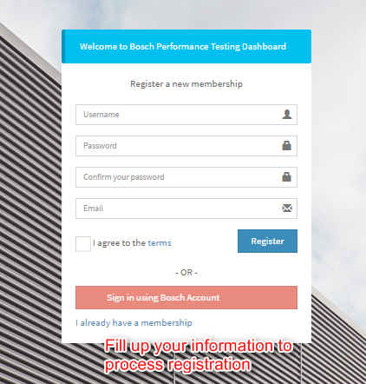

Figure 2 Register form

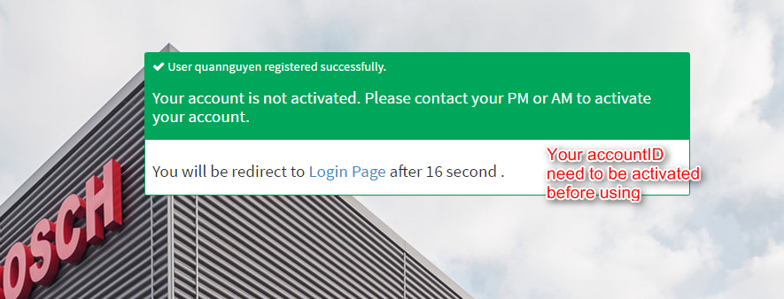

Figure 3 Successful message after registration

# Admin

## Admin view for Perforamnce testing Dashboard

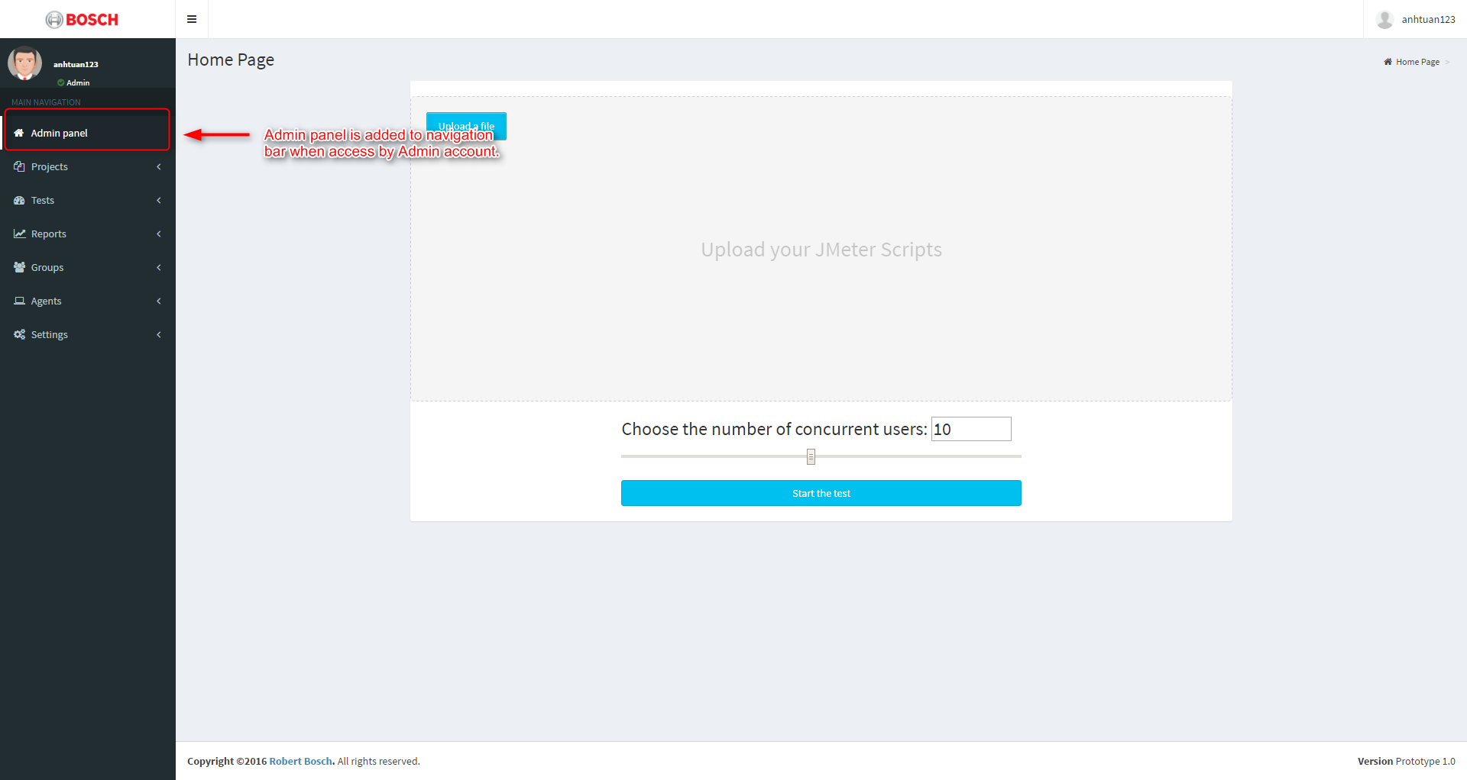

Figure 4 Admin page link on the Leftside menu

Admin panel will show the management panel of entities when open.

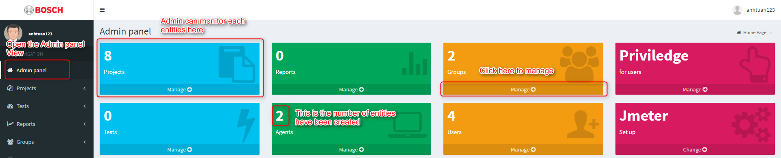

Figure 5 Admin panel interface

## Created/Edit Entities

In admin panel, we can interact with Projects, Reports, Groups, Privilege, Tests, Agents, Users and Jmeter Setup.

* Project: Create – View – Edit – Delete
* Report: View – Delete
* Groups: Create – View – Edit – Delete
* Privilege: Create – View – Edit – Delete
* Tests: Create – View – Edit – Delete
* Agents: Create – View – Edit – Delete
* Users: Create – View – Edit – Delete
* Jmeter: Create – View – Edit – Delete

## Project management

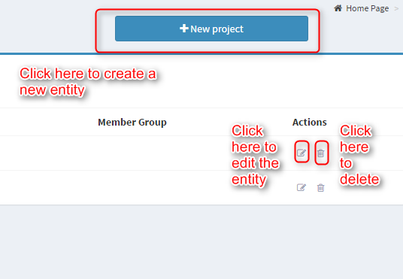

Figure 6 Project management buttons

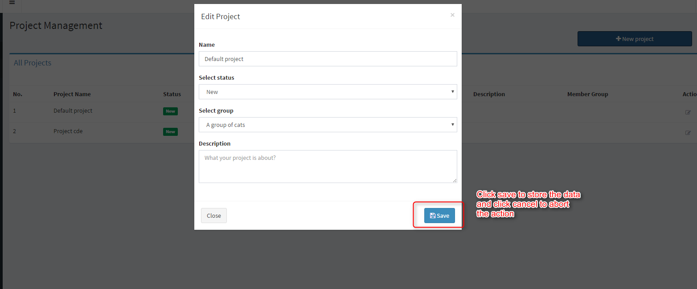

Figure 7 Create project form

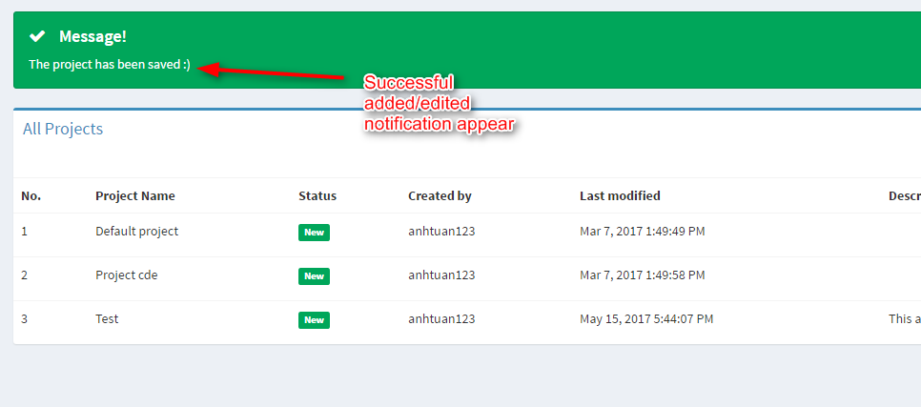

Figure 8 Project list and successful message after project creation

## Group management

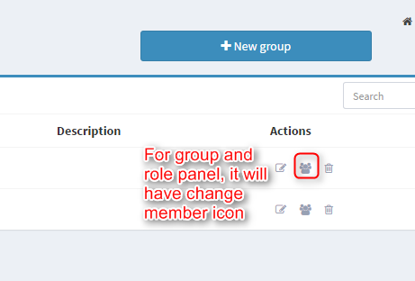

Figure 9 Group management buttons

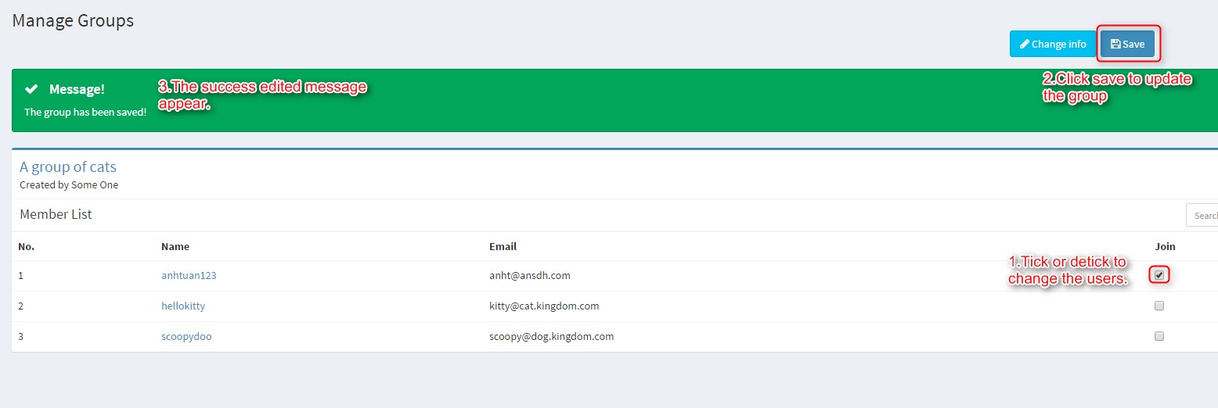

Figure 10 Manage user in a group

## Jmeter configuration management

For Jmeter Setup, we can use switch icon to choose the current Jmeter Configuration for the application.

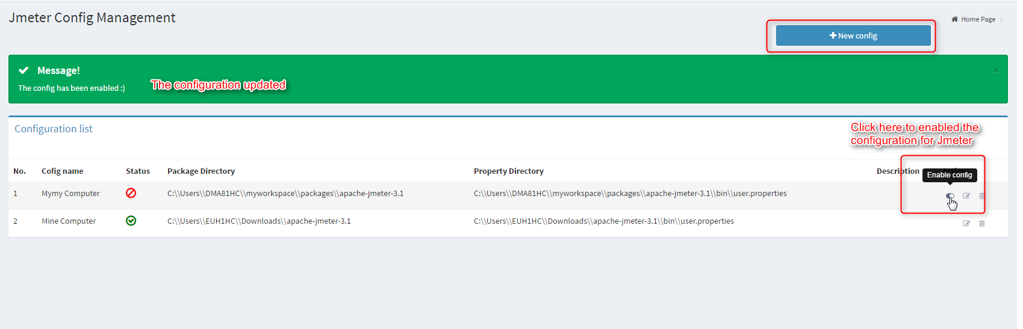

Figure 11 Configuration management page

# Users

## For Users as Testers

Tester can only create tests from the projects of the group they are currently a member.

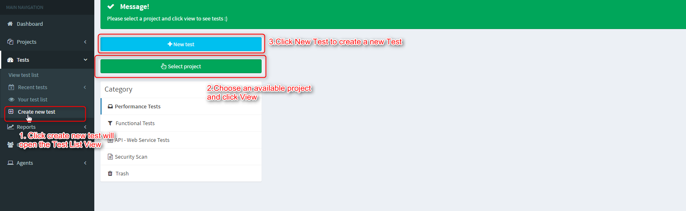

Figure 12 Test Suite main page

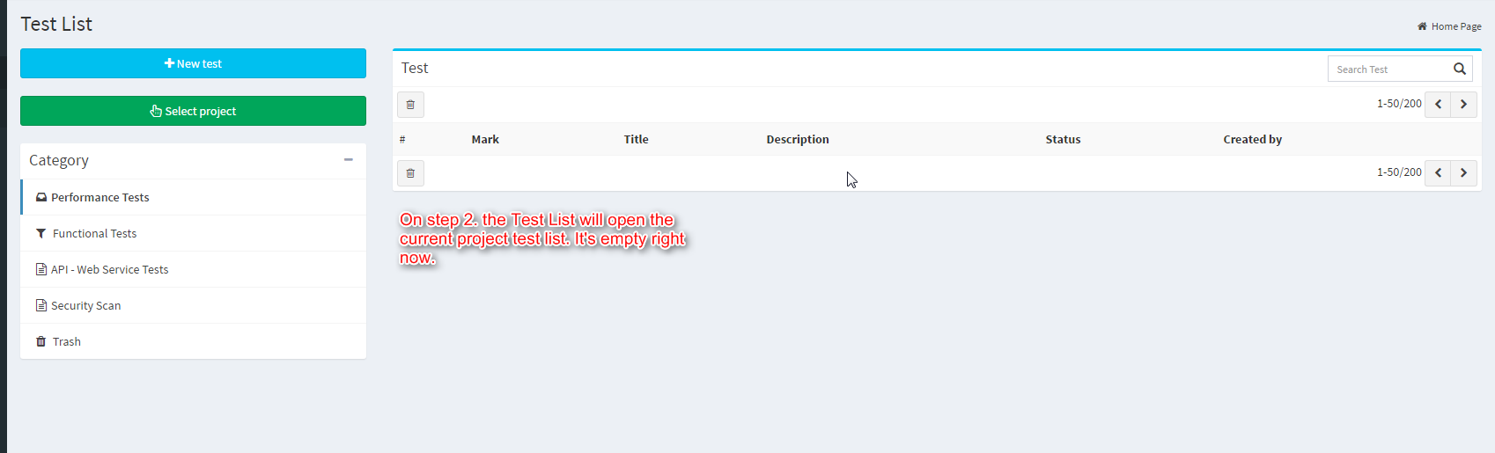

Figure 13 Test listing table

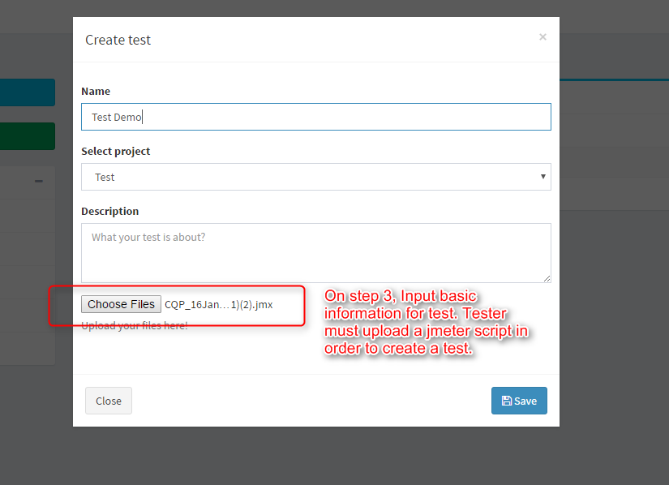

Figure 14 Create test form

You will be ask to upload Jmeter if you input wrong file format. You will be ask to upload Jmeter if you input wrong file format.

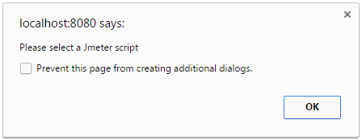

Figure 15 Warning message when you do not upload Jmeter script for the test

After create a test, the application will direct the tester to new created test detail.

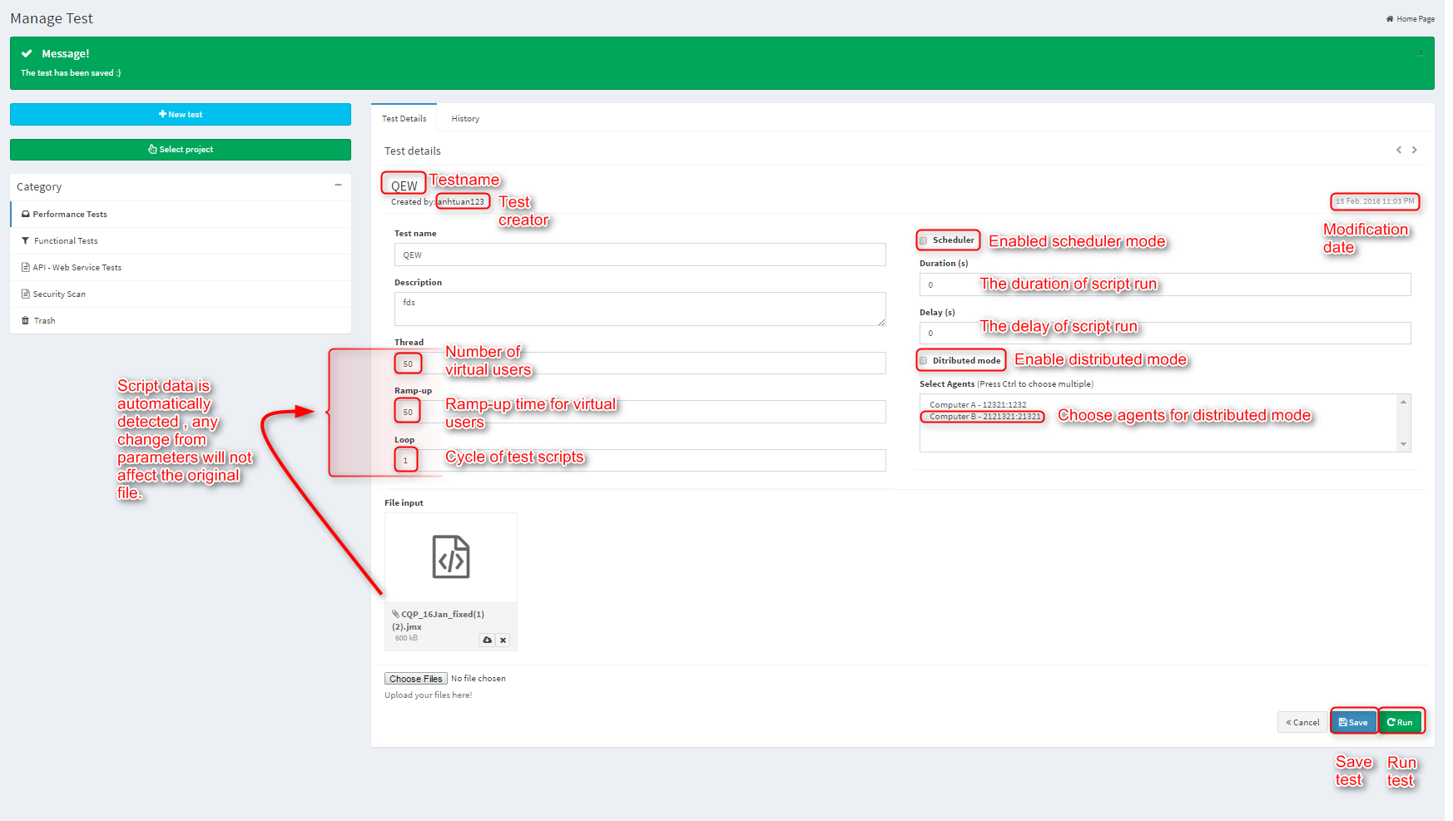

Figure 16 Details of a Test Suite

Click Run Test to execute Test Suite or Click Save to update the test.  
For Stepping Thread Group script, it will also detect the script properties and create the view for this script.

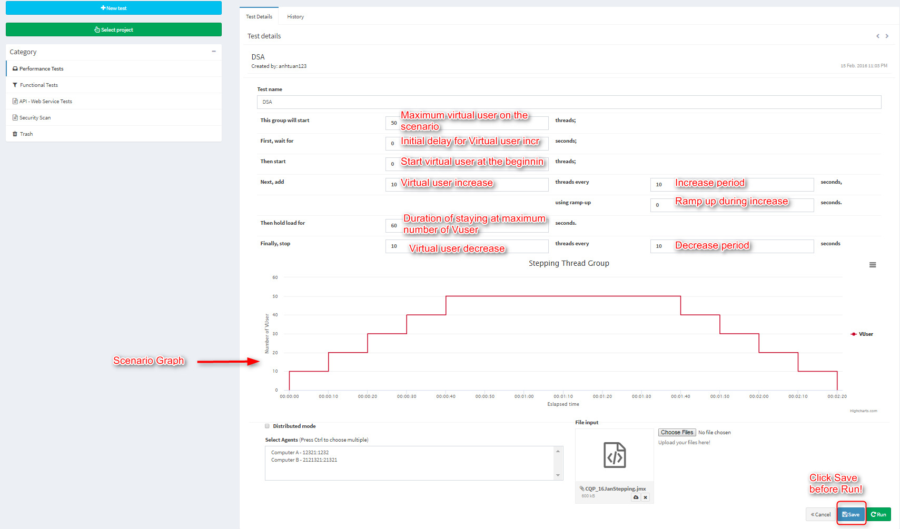

Figure 17 Graphical interface for changing scipt parameters

Please save first before running the test script.

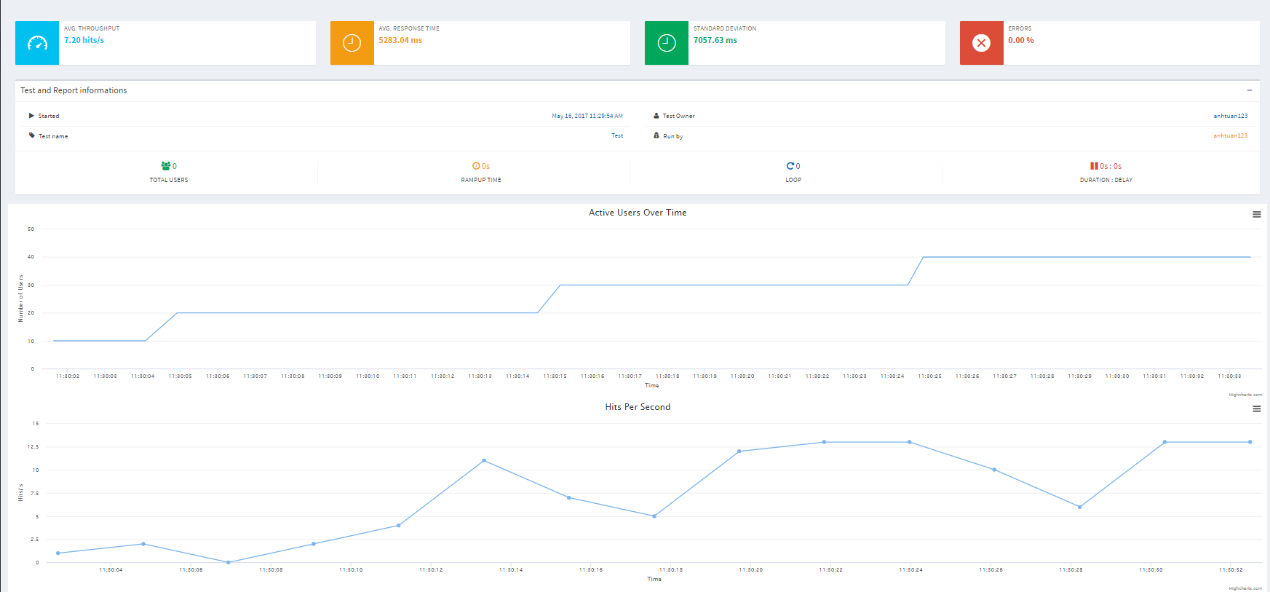

Figure 18 Real-time report for running a test suite

The test will be redirect to the real-time report. After the test execution finished, it will create summary and statistics overview for the test execution and finished graph. The report will have 4 graphs: Active Users over Time, Hits per Second, Response Time over Time, Throughput.

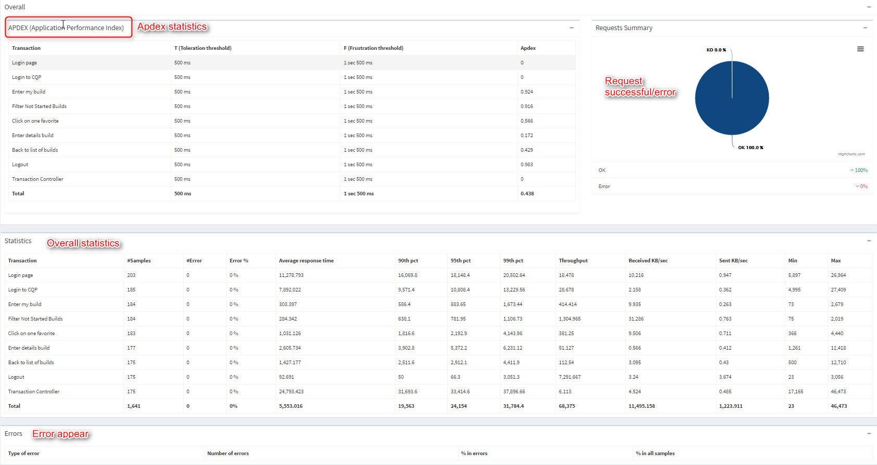

Figure 19 Final report tables when test runtime finished

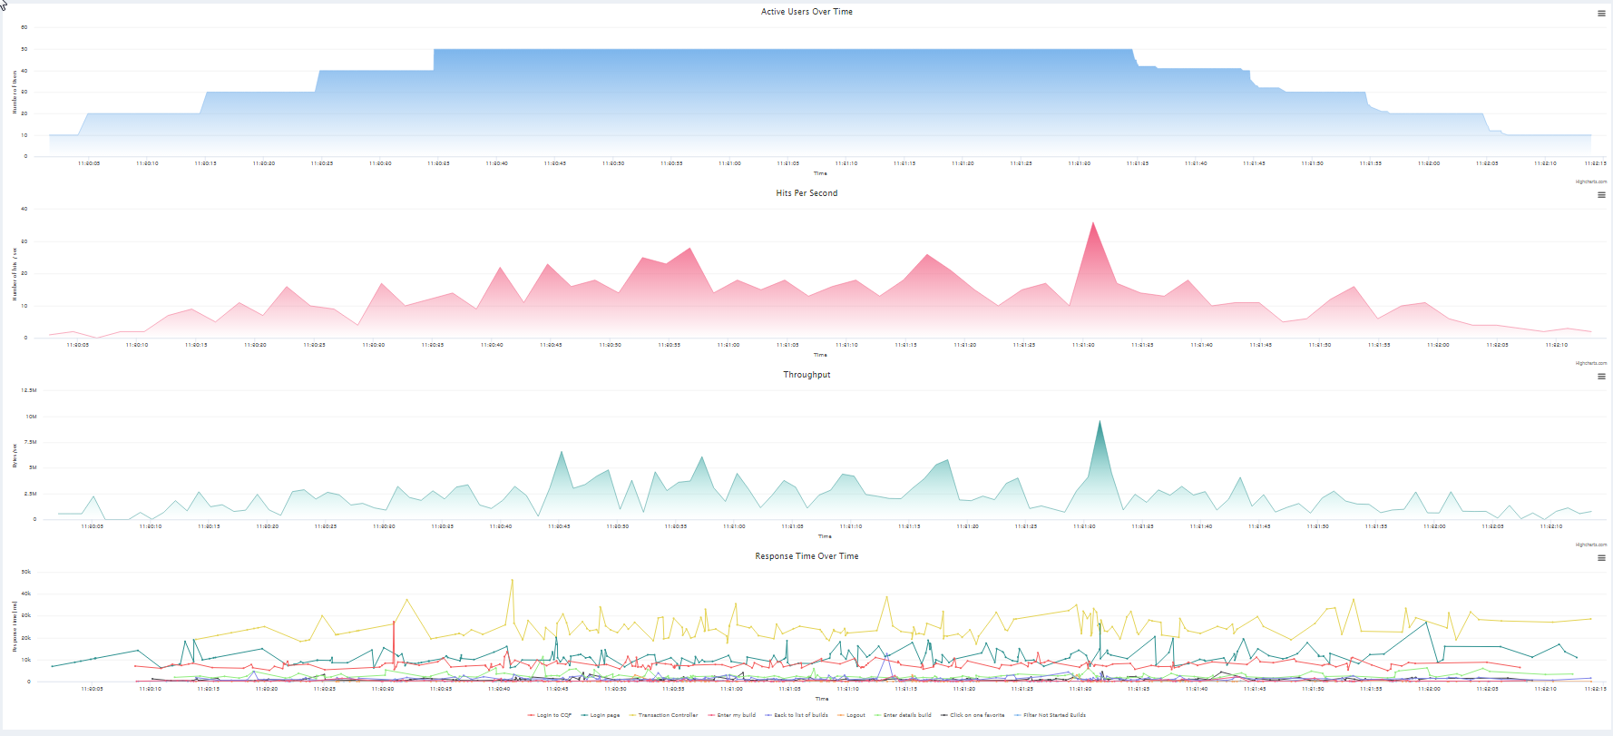

Figure 20 Final report charts when test runtime finished

Each charts can be exported and supporting many format types.

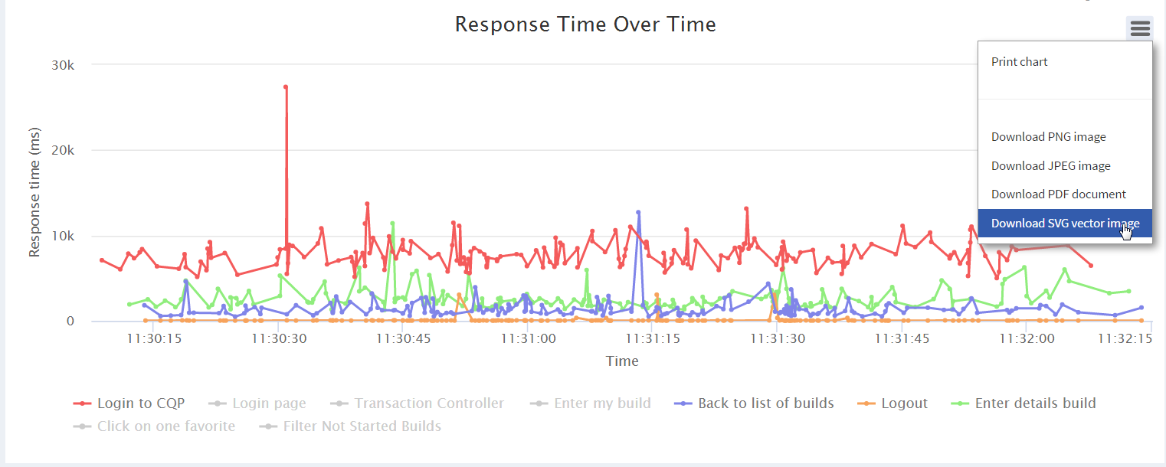

Figure 21 Export chart options

We can view previous test run report on history tab on test Detail.

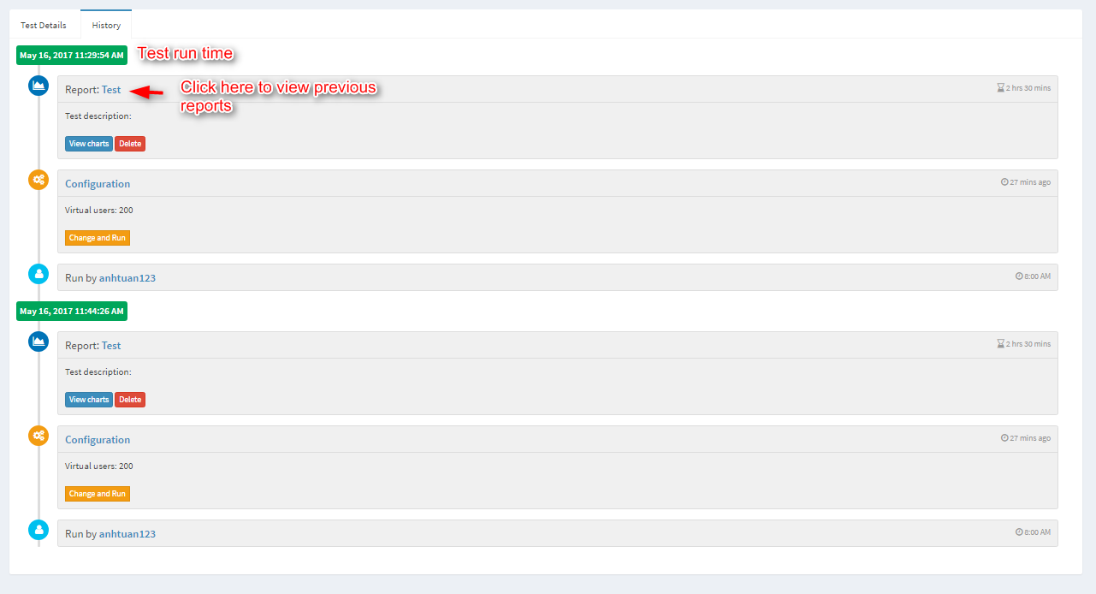

Figure 22 Runtime history of a test suite

From User Profile we can see the latest entities that we have interacted with.

## Profile management

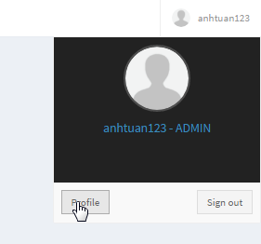

Figure 23 Profile page link

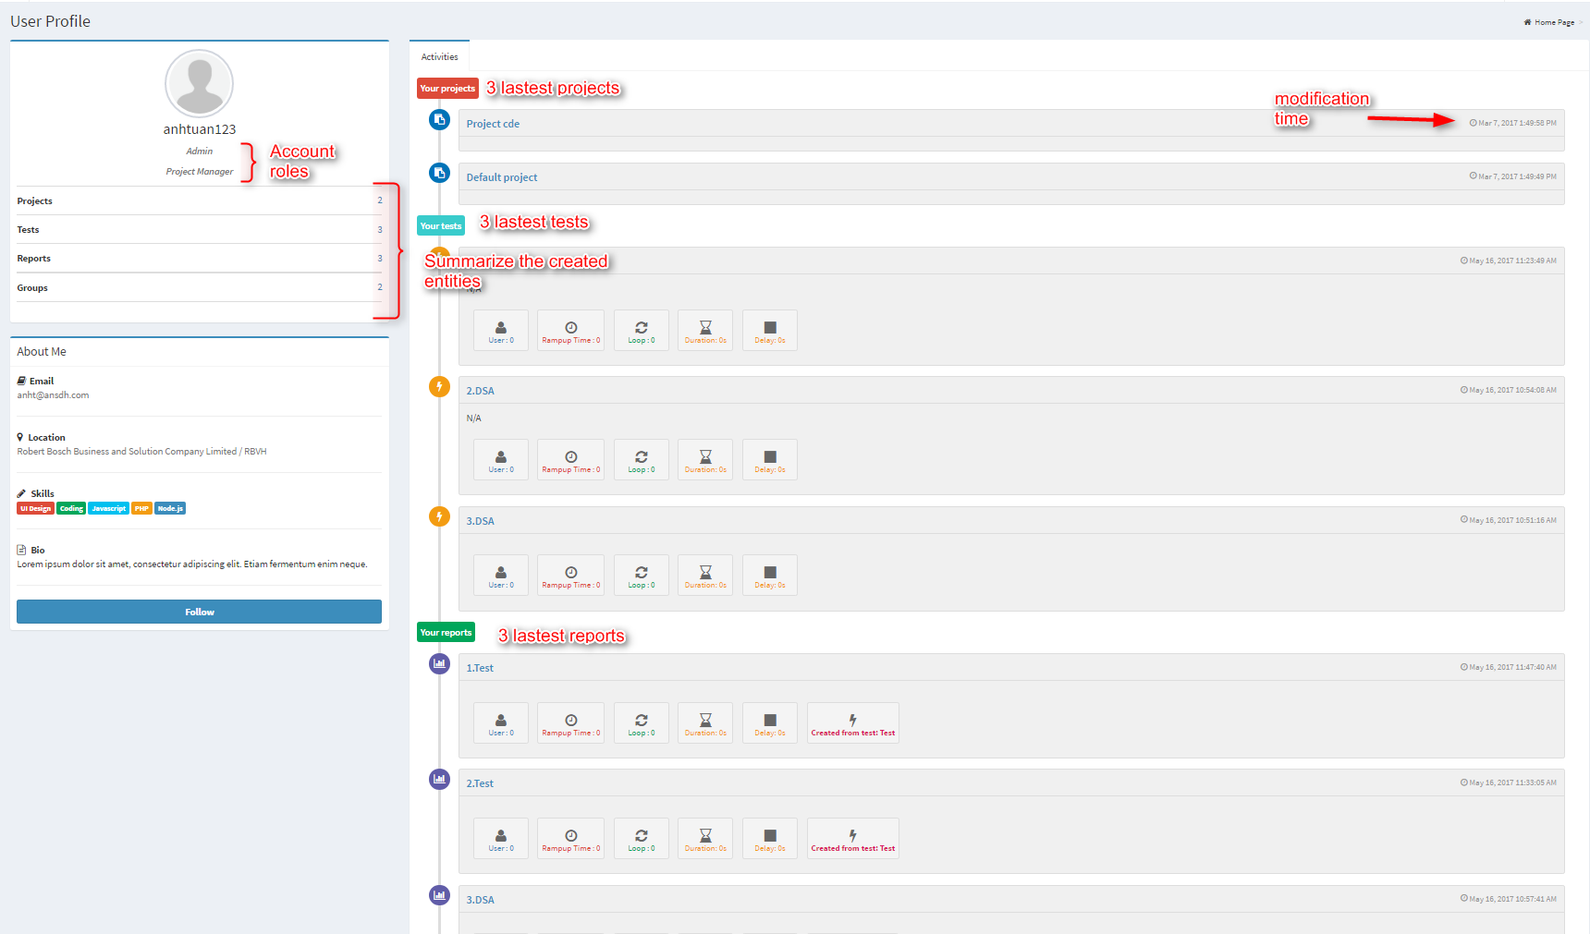

Figure 24 User profile page

## Users as Project Mangers

Meet hellokitty, she’s a project manager from validation team.

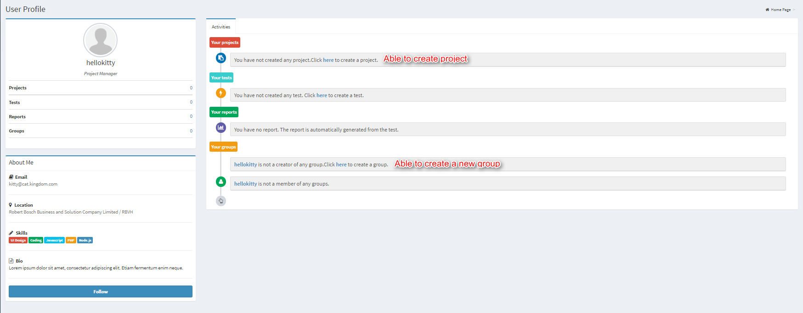

Figure 25 Admin user profile

Not only creating tests, she have the privilege to create new project and new group.

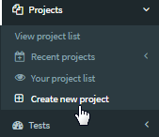

Figure 26 Project menu options for admin users

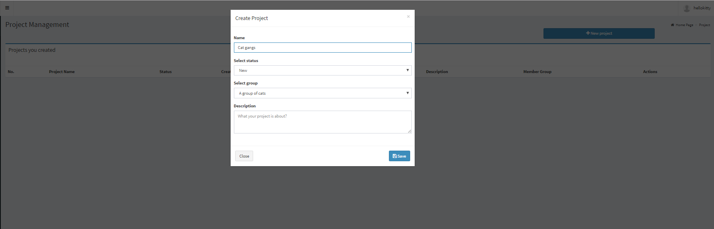

Figure 27 Create Project form

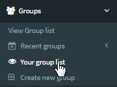

Figure 28 Group management menu options

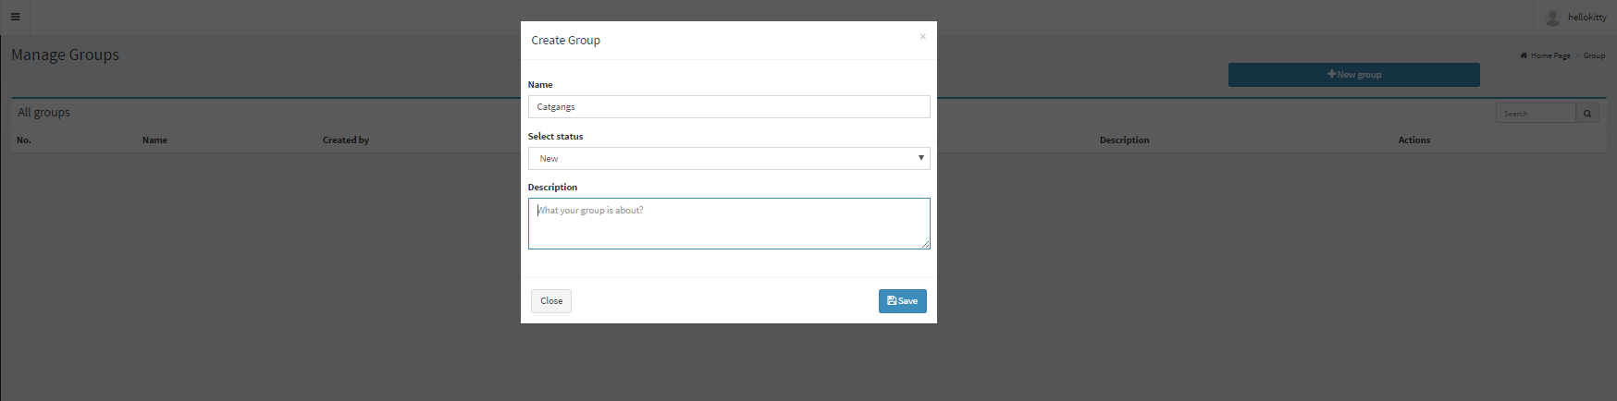

Figure 29 Create group form

The project manager can access to project navigation bar and group navigation bar to create projects and groups they wanted.

If the Users want to add new Agent or configure Jmeter properties, they will need for Admin Account or granted Admin role from another Admin.